

**Green University of Bangladesh**

**Department of Computer Science and Engineering (CSE)**

**Faculty of Sciences and Engineering**

**Semester: (Summer, Year:2022), B.Sc. in CSE (Day)**

**Course Title : Data Structure**

**Course Code : CSE 106**

**Section : D2**

**Student Details**

|  |  |  |
| --- | --- | --- |
| **Name** | | **ID** |
| **1.** | Jahidul Islam | 221002504 |
| **2.** |  |  |
| **3.** |  |  |

**Submission Date : 8 November, 2022**

**Course Teacher’s Name : Umme Habiba**

**[For Teachers use only: Don’t Write Anything inside this box]**

|  |
| --- |
| **Marks: ………………………………… Signature: .....................**  **Comments: .............................................. Date: ..............................** |

**1. Implement linear search algorithms using recursion.**

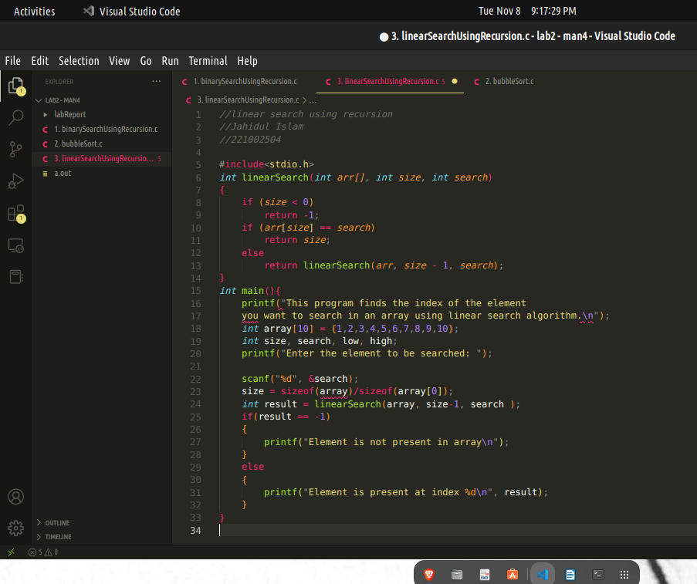

**Output of solution 01:**

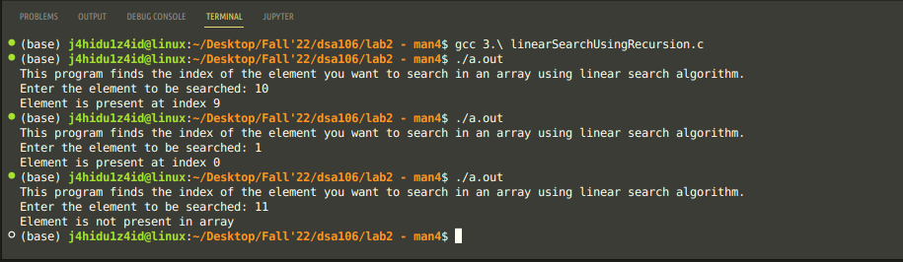

**2. Implement Insertion Sort algorithm using Arrays**

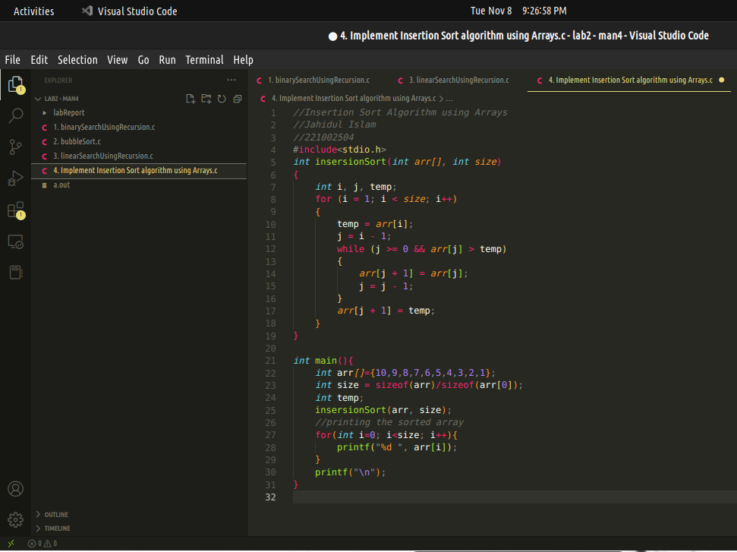

**Output of solution 02:**

